**EGR 7040**

**Project Update**

**Proposal Review**

In the original proposal submission, the goal of the project was to optimize a bridge design comprised of trusses. Cost function was the mass of the structure while the constraint is the yield strength of the chosen material. Before continuing any further it is noted that the original design proposal has been modified according to the Figure 1 below.

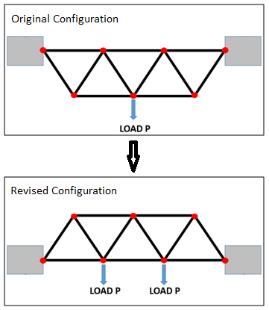

Figure 1: Design change schematic

The revised configuration is more indicative of a bridge structure and is the primary reason for the change. In the original proposal; dimensions, loads, and material properties were not identified. The following section shall now discuss these matters in more detail. The revised model still comprises of 6 nodes and 11 truss elements.

**Design and Load Specifications**

Length of each truss element is set to be 3m long. This is typical truss dimensions found in engineering statics texts. Using this dimension will yield a bridge of 9m in length. This is a relatively short bridge design and is intended to span small ravine or river. The intent of the proposed bridge is to allow crossing of commercial and private vehicles along with any potential foot traffic. Due to loading and stiffness requirements, the goal is to design a bridge that can hold 5000 kN applied at two locations on the mid-span. Final bridge proposal can be seen below in Figure 2.

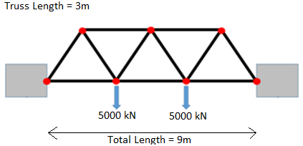

Figure 2: Final bridge dimensions and load carrying requirements.

Almost universally, steel is the choice of material used for bridge construction. Typically, steel alloy grades can be specified via chemical composition or mechanical strength properties such as yield strength (σy). Since yield strength is the constraint on the bridge design following steel grades were chosen for the study.

|  |  |  |
| --- | --- | --- |
| **Steel Allow Table** | | |
| Steel Nomenclature | Yield Strength | Price per Ton |
| 270 Steel | 270 MPa | $550.00 |
| 340 Steel | 340 Mpa | $650.00 |
| 420 Steel | 420 Mpa | $700.00 |
| 550 Steel | 550 Mpa | $950.00 |

Table 1: Steel properties and costs.

The values used in the table above were obtained through material specifications and current steel prices listed by vendors on-line. It should be noted that steel prices can vary significantly in short period of time so quoted prices above may not be accurate a month from now. Besides the tabulated properties above, additional parameters needed are Young’s Modulus and Density, which for each steel listed above are defined as E = 200 Gpa and ρ = 7850 kg/m3.

**Analysis Procedure**

As stated in the original proposal, the goal of the project was to code a truss finite element solver (FEA) in Matlab to calculate loads and displacements in each joint and truss member. The FEA solver can be used in conjunction with the optimization toolbox in Matlab to perform the optimization procedure.

The FEA solver constructed in Matlab was verified using commercially available FEA package called ABAQUS, which is widely used in academia and industry. Table below lists results obtained in Matlab and ABAQUS for a truss cross section area of A = 0.020 m2.

|  |  |  |
| --- | --- | --- |
| **Stress Results for Matlab and ABAQUS analysis** | | |
| **Element #** | **Matlab Stress** | **ABAQUS Stress** |
| 1 | 288.7 MPa, C | 288.7 MPa, C |
| 2 | 288.7 MPa, C | 288.7 MPa, C |
| 3 | 48.1 MPa, C | 48.1 MPa, C |
| 4 | 96.2 MPa, T | 96.2 MPa, T |
| 5 | 48.1 MPa, C | 48.1 MPa, C |
| 6 | 288.7 MPa, C | 288.7 MPa, C |
| 7 | 288.7 MPa, T | 288.7 MPa, T |
| 8 | 0 MPa | 0 MPa |
| 9 | 0 MPa | 0 MPa |
| 10 | 288.7 MPa, T | 288.7 MPa, T |
| 11 | 288.7 MPa, C | 288.7 MPa, C |

Table 2: Analysis results for Matlab and ABAQUS FEA solves.

Table 2 shows identical results for both solvers. Letter “C” and “T” denote that the subject truss element is either in compression or tension respectively. Due to structure and loading symmetry the stress distribution is also symmetric. This is more evident in the ABAQUS stress output below (Figure 3).

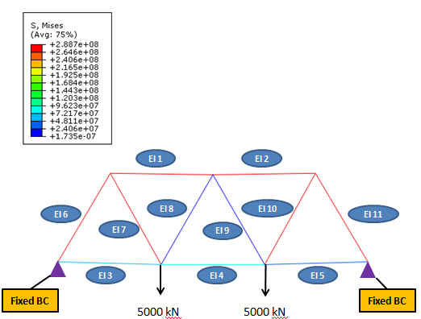

Figure 3: ABAQUS stress results for cross section area of 0.020 m2.

Figure 3 also identifies individual truss elements, which can be used in conjunction with Table 2.

**Preliminary Optimization Results**

Now that the Matlab FEA solver has been verified, optimization was carried out on the four steel variants listed in Table 1. While the cost function is linear the stress constraints are not. As such, Matlab function “FMICON” was used to solve the optimization problem. Each time element cross sectional areas were modified by “FMINCON” the constraint functions called on the FEA solver to generate new stress results that can be used to verify the stress constraints. The cost function is simply a summation of each element mass, which is defined as density*length*cross-sectional-area.

Each of the four optimization runs took 11 iterations to converge. Algorithm used was interior-step. For the initial designs all element cross section areas were set to 0.020 m2. This results in a bar with cross-sectional dimensions that are approximately 141mm by 141mm. Optimization results are tabulated below for all the steel variants along with the projected costs.

|  |  |  |  |
| --- | --- | --- | --- |
| **Optimization Summary** | | | |
| **Alloy Grade** | **Starting Mass (kg)** | **Ending Mass (kg)** | **Cost ($)** |
| 270 | 5181.0 | 3281.6 | 1805.00 |
| 340 | 5181.0 | 2607.6 | 1695.00 |
| 420 | 5181.0 | 2112.5 | 1479.00 |
| 550 | 5181.0 | 1615.0 | 1534.00 |

Table 3: Optimization results.

While using 550 steel alloy yields the lightest structure, due to cost considerations alloy 420 is a better choice. It is seen that obtaining cheaper steel alloys do not provide a cost advantage once selection goes below 420 grade.

**Summary**

Optimization analysis of a conventional truss bridge was carried out. Stress in the truss members was calculated via FEA technique that was employed inside Matlab. Stress results obtained from Matlab were confirmed by ABAQUS CAE software, which a commercial package widely used in academia and industry.

Preliminary results were carried out on four steel grades each of which were listed in Table 1 along with approximate pricing. Optimization analysis was performed using function “FMINCON”. Results in Table 4 indicate that best tradeoff between cost and material performance is found in alloy steel grade 420. This option does not yield the lightest structure but it is the most cost effective option.

**Appendix**

**Iteration Results**

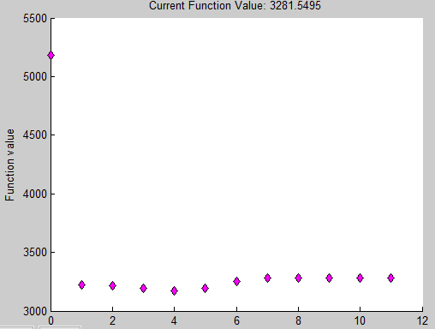

Figure 4: Optimization results for steel alloy 270.

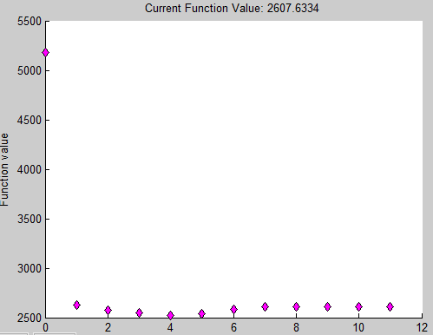

Figure 5: Optimization results for steel alloy 340.

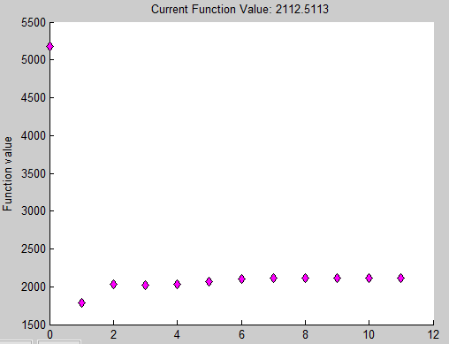

Figure 6: Optimization results for steel alloy 420.

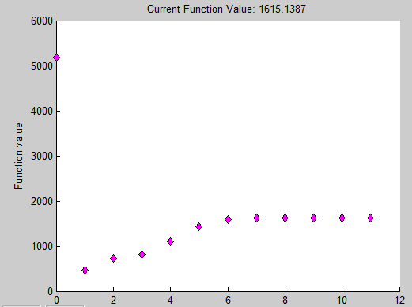

Figure 7: Optimization results for steel alloy 550.